

INTEGRATED OFFICE APPLICATIONS
(215)

NATIONAL 2020

Production Portion:

Job 1: Database Report (150 points)
Job 2: Letter Mail Merge (150 points)
Job 3: Query (150 points)
Job 4: PowerPoint (150 points)
TOTAL POINTS (600 points)

Failure to adhere to any of the following rules will result in disqualification:
- Contestant must hand in this test booklet and all printouts. Failure to do so will result in disqualification.
- No equipment, supplies, or materials other than those specified for this event are allowed in the testing area. No previous BPA tests and/or sample tests or facsimile (handwritten, photocopied, or keyed) are allowed in the testing area.
- Electronic devices will be monitored according to ACT standards.

No more than ten (10) minutes orientation
No more than ninety (90) minutes testing time
No more than ten (10) minutes wrap-up

Property of Business Professionals of America.
May be reproduced only for use in the Business Professionals of America
Workplace Skills Assessment Program competition.

GENERAL INSTRUCTIONS

- Make certain this test booklet contains the Jobs 1-4.
- Key all jobs according to the instructions given.
- Correct any obvious keyboarding errors and incorporate any editing notations.
- Correct any errors in formatting. Use formatting shown in the Style & Reference Manual.
- For any problem where you would normally key your reference initials, key your contestant number. Your name or initials should not appear on any work you submit.
- Key your contestant number and job number as the footer in the lower left-hand corner of all work submitted unless otherwise specified.
Example:
99-9999-9999
Job 1

- If you finish before the end of the allotted testing time, notify the proctor. Time may be a factor in determining a winner when there is a tie score.
- When turning in your materials, place your scoring sheet on top of your jobs. The jobs should be arranged in numerical order. Turn in all partial jobs completed.
Production Standards

0 Errors | 100 points
1 Error | 90 points
2 Errors | 70 points
3 Errors | 50 points
4+ Errors | 0 points

SCORING SHEET
Job 1 – Database Report | Possible  Points | Points Awarded
Data Input Correctly (Production Standards) | 100
0 errors - 100 points, 1 error - 90 points, 2 errors - 70 points,  3 errors – 50 points, 4+ errors – 0 points | 100
Report Sorted by Fee in Ascending Order | 10
Printed using no grouping, tabular, & landscape. | 10
Report Title is Leadership Conference Speakers | 10
All fields included, no items truncated or overlapping | 10
Contestant & Job Number in Footer | 10
Job 1 Total | 150
Job 2 – Letter Mail Merge | Possible  Points | Points Awarded
Data Input Correctly (Production Standards) | 100
0 errors - 100 points, 1 error - 90 points, 2 errors - 70 points,  3 errors – 50 points, 4+ errors – 0 points | 100
Merge Fields Inserted | 30
Used fields instead of Address and Greeting block | 10
Printed letter with merge fields showing and highlighted | 10
Job 2 Total | 150
Job 3 – Query | Possible  Points | Points Awarded
Data Input correctly (Production Standards))  0 errors - 100 points, 1 error - 90 points, 2 errors - 70 points,  3 errors – 50 points, 4+ errors – 0 points | 100
Report Grouped by Pay Rate, stepped, & landscape. | 20
Report title is Employee Pay Rate Query | 10
Contestant & Job Number in Footer | 10
Fields Adjusted so nothing is overlapped or truncated | 10
Job 3 Total | 150

Job 4 – PowerPoint | Possible  Points | Points Awarded
Data Input Correctly (Production Standards)  0 errors - 100 points, 1 error - 90 points, 2 errors - 70 points,  3 errors – 50 points, 4+ errors – 0 points | 100
Theme Applied | 10
Printed 2 Slides Per Page | 10
Contestant and Job number in handout footer | 10
Graphics added & Fit Presentation | 10
Added Mr. Rosen’s title and corrected spelling errors | 10
Job 4 Total | 150
TOTAL POSSIBLE | 600

Job 1: Database

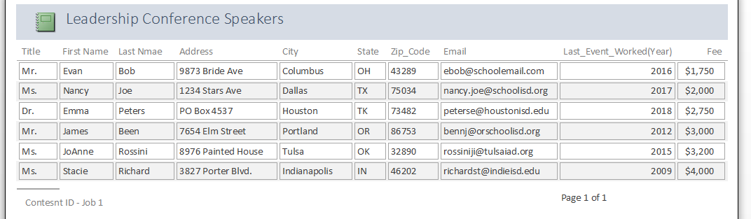
Job 2: Letter with Merge

Current Date
Graders note:
Top Margin should be 2”

«Title» «First_Name» «Last_Nmae»
«Address»
«City», «State» «Zip_Code»

Hello «First_Name»

Bids Open for June Leadership Conference Speakers.

Professional Business Associates is opening the bidding process for our keynote speaker at our next Leadership Conference. Since you presented with us in «Last_Event_Worked_Year», we wanted to invite you to bid for our next Leadership Conference.

Bids need to include all costs for you to attend our Leadership Conference occurring next year in July. Bids cannot be adjusted after they have been sent to us for voting. Bids will need to cover the following needs for our conference:

- Keynote Address
- Exhibit Booth in the Exhibit hall all days of the conference
- Leadership Pull out Sessions – 3 -5 DIFFERENT sessions offered and scheduled depending on room availability.
- Please list all the session options we would be able to choose from.

Please also include a bid that contains all the above information but adjusted to exclude the keynote address. Bids need to be sent to our office no later than August 15th.

Sincerely

Roger Myer, Manager
Marketing Department

Contestant ID

Job 3: Database

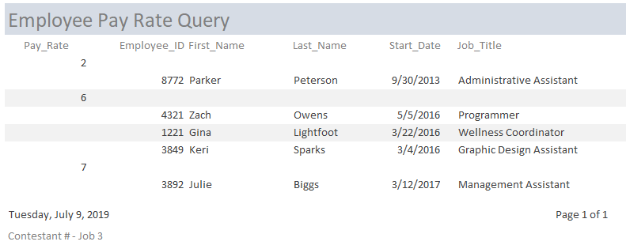

Job 4 – Presentation:

Grader Notes: Slides are Blown Up for Grader Readability! Errors to be corrected are Italic, Underlined and shadowed in the PowerPoint.

